H.T No
Regulations:
A18

Sreenidhi Institute of Science and Technology
(An Autonomous Institution)
Code No: 7HC03 Date: 21-Mar-2023 (AN)

B.Tech I-Year I- Semester External Examination, March/April-2023 (Supplementary)
CHEMISTRY (CIVIL, CSE, IT and ECM)

Time: 3 Hours Max.Marks:70

Note: a) No additional answer sheets will be provided.
b) All sub-parts of a question must be answered at one place only, otherwise it will not be valued.
c) Missing data can be assumed suitably.
Bloom's Cognitive Levels of Learning (BCLL)

Remember | L1 | Apply | L3 | Evaluate | L5
Understand | L2 | Analyze | L4 | Create | L6

Part - A Max.Marks:20

Answer all QUESTIONS.

 |  | BCLL | CO(s) | Marks
1 | He₂ molecule does not exist. Justify. | L2 | CO1 | [2M]
2 | Name the main vulcanizers used in vulcanization of rubber. | L2 | CO2 | [2M]
3 | Express the units of hardness of water. | L2 | CO3 | [2M]
4 | Discuss the significance of salt bridge in electrochemical cell. | L2 | CO4 | [2M]
5 | Propose why rusting of iron is quick in saline water than in ordinary water. | L3 | CO5 | [2M]
6 | Mention its uses and side effects of Ibuprofen. | L2 | CO6 | [2M]
7 | “Teflon is called as Wonder Plastic”. Justify the statement. | L3 | CO2 | [2M]
8 | Distinguish between the terms EMF and single electrode potential | L4 | CO4 | [2M]
9 | Write the IUPAC Name of Paracetamol. | L2 | CO6 | [2M]
10 | Explain the effect of temperature on Viscosity of Liquids. | L2 | CO2 | [2M]

Part – B Max.Marks:50
ANSWER ANY FIVE QUESTIONS. EACH QUESTION CARRIES 10 MARKS.

 |  |  | BCLL | CO(s) | Marks
11. | a) | On the basis of MOT Explain molecular orbital energy level diagram of O_{2.} | L3 | CO1 | [5M]
 | b) | Based on Molecular orbital theory explain LCAO. | L2 | CO1 | [5M]
12. | a) | Define Lubricants. Extend a note on the classification of lubricants with examples. | L2 | CO2 | [5M]
 | b) | Outline the method of synthesis and applications of the following polymers:  i)Teflon (ii) Nylon 6 | L3 | CO2 | [5M]
13. | a) | Explain the principle involved in reverse osmosis of desalination. List the main advantage of reverse osmosis over ion-exchange process. | L2 | CO3 | [5M]
 | b) | Determine the temporary, permanent and total hardness in ppm units for a water sample which showed the following analysis. Given CaCO3 = 32.4 mg/lit, MgCO3 =29.2 mg/lit, NaCl = 5.85mg/lit, CaCl2 = 22.2 mg/lit, MgSO4 = 1.2 mg/lit, organic matter = 15.5mg/lit. | L3 | CO3 | [5M]
14. | a) | Discuss about Hydrogen-Oxygen fuel cell with a neat design and chemical reactions. List out the applications of fuel cells. | L3 | CO4 | [5M]
 | b) | A cell whose resistance when filled with 0.1N KCl solution is 192.3 ohms was found to be 6306 ohms when filled with 0.01N NaCl solution at 25⁰C,Specific conductance of KCl is 0.00289 ohm⁻¹ cm⁻¹. Measure  i)cell constant  ii)Specific conductance of NaCl solution  iii)Equivalent conductance of NaCl solution | L3 | CO4 | [5M]
15. | a) | Make use of cell reactions and explain the mechanism of electrochemical corrosion by oxygen consumption. | L3 | CO5 | [5M]
 | b) | Discuss how metals are protected by different hot dipping processes. | L3 | CO5 | [5M]
16. | a) | State and explain Markownikoff’s rule. Why does the rule fail during the addition of HBr in presence of peroxide? | L3 | CO6 | [5M]
 | b) | Discuss the principle and applications of Rotational Spectroscopy | L3 | CO6 | [5M]
17. | a) | Apply MOT diagrams and calculate the bond order in He₂⁺ and Be_{2.} | L3 | CO1 | [4M]
 | b) | Discuss the term “Elastomers”. Explain the synthesis, properties and applications of BUNA-S. | L3 | CO2 | [3M]
 | c) | How Calgon works in conditioning the boiler feed water. | L3 | CO3 | [3M]
18. | a) | Write a note on Quinhydrone Electrode with cell reactions and cell notation. Give the advantages of Quinhydrone Electrode. | L3 | CO4 | [4M]
 | b) | Differentiate Electroplating from Electroless Plating. | L3 | CO5 | [3M]
 | c) | Explain the mechanism for the following Reactions.  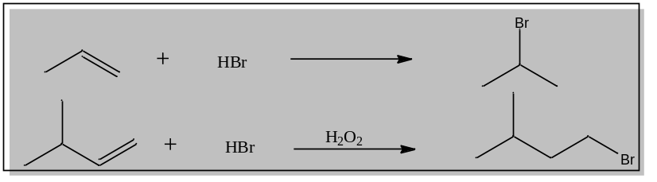 | L3 | CO6 | [3M]

-- 00 -- 00 –

